<https://leetcode.com/discuss/interview-question/373006>

Amazon | OA 2019 | Favorite Genres

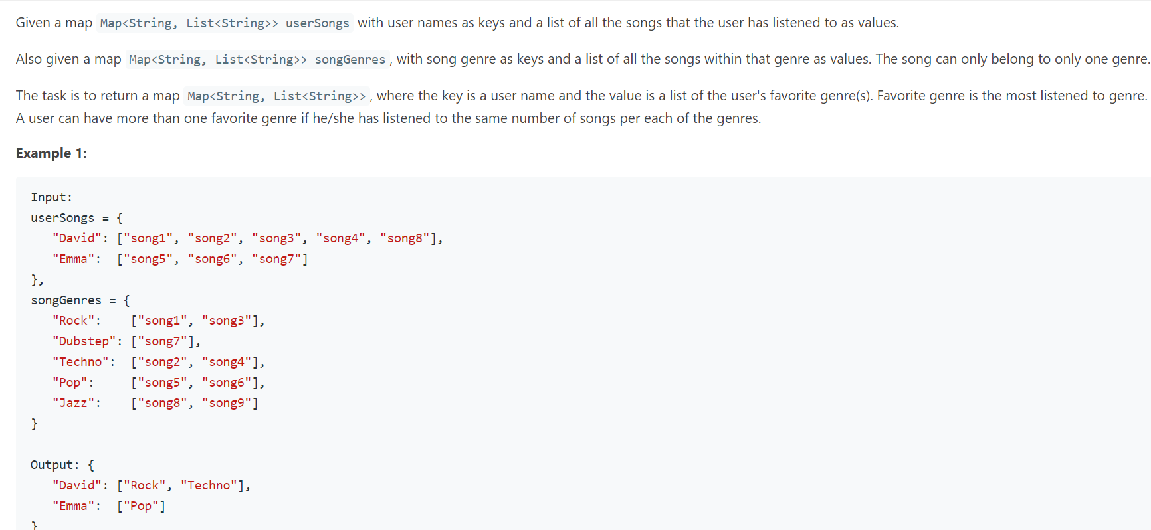

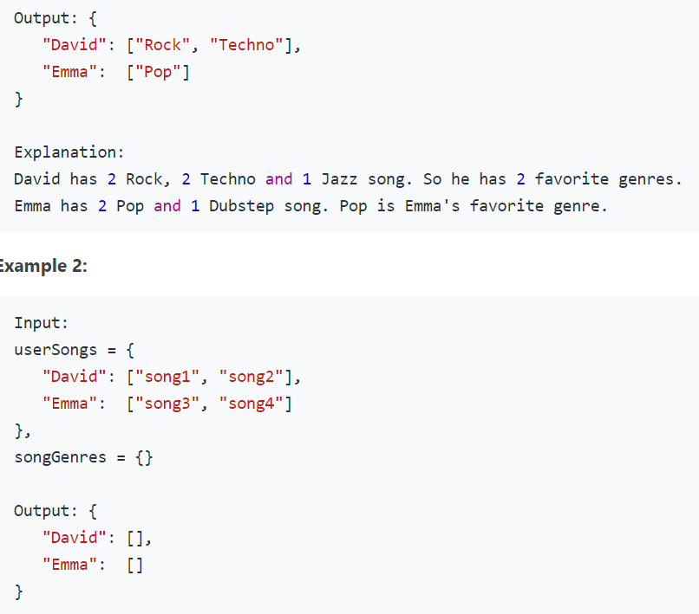

Map<String, List<String>> favoriteGenre(Map<String, List<String>> userSongs, Map<String, List<String>> songGenres) {

Map<String, String> songToGenre = new HashMap<>();

songGenres.forEach((genre, songs) -> songs.forEach(song -> songToGenre.put(song, genre)));

Map<String, List<String>> favoriteGenre = new HashMap<>();

userSongs.forEach((user, songs) -> favoriteGenre.put(user, calculateFavoriteGenre(songs, songToGenre)));

return favoriteGenre;

}

private List<String> calculateFavoriteGenre(List<String> songs, Map<String, String> songToGenre) {

Map<String, Integer> genreFrequency = new HashMap<>();

List<String> favoriteGenre = new ArrayList<>();

int maxFrequency = 0;

for (String song : songs) {

String genre = songToGenre.get(song);

Integer frequency = genreFrequency.merge(genre, 1, (ov, nv) -> ov + 1);

maxFrequency = max(frequency, maxFrequency);

}

for (Map.Entry<String, Integer> entry : genreFrequency.entrySet()) {

if (entry.getValue() == maxFrequency) {

favoriteGenre.add(entry.getKey());

}

}

return favoriteGenre;

}